**Assignment 3**

**Question 1**



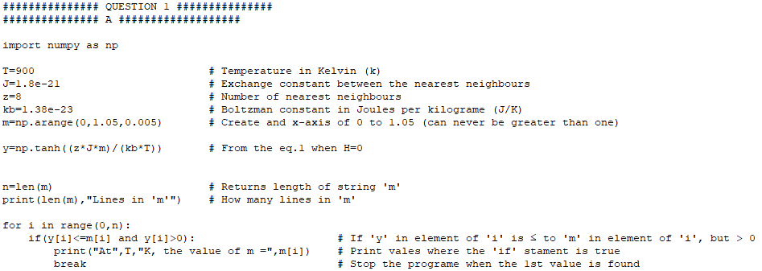

**Fig 1.1:** code to calculate a value of $m$ at temperature $T$ and what printed to the shell.



Fig 1 shows the value of magnetisation, $m=0.61 A m^{-1}$ at $900 K$. Where there the applied field, $H=0$ (**Eq.1.1**)

Increasing or decreasing the temperature, $T$ yields different results for magnetisation, $m.$ As can be seen below.

**Decreasing** the temperature yields:



**Increasing** the temperature yields:



It can bee seen that the material performs better under lower temperatures. This is due to magnets preforming at their maximum magnetization when the magnetic moments are parallel ($0 K$). These magnetic moments align more closely while at low temperatures.

This code was used to find a value of magnetization, $m$ at temperature, $T$. The next bit of code was written to see how $m$ vairies with $T$ without having to keep changing $T$ manually.

It was then necessary to plot $m$ as a function of $T$. This should look like the **Fig 1.12** Below

**Fig 1.12:** How the magnetization, $m$ should vary with at temperature $T$ increases.

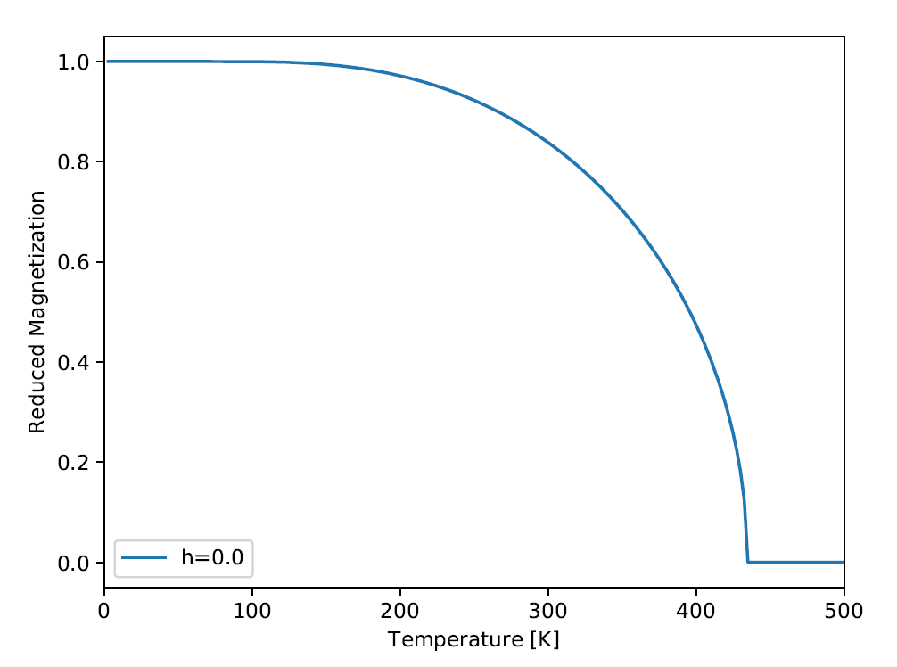

I was unsuccessful in plotting the curve. However, I was able to gather the date required with the following code (**Fig 1.13**)

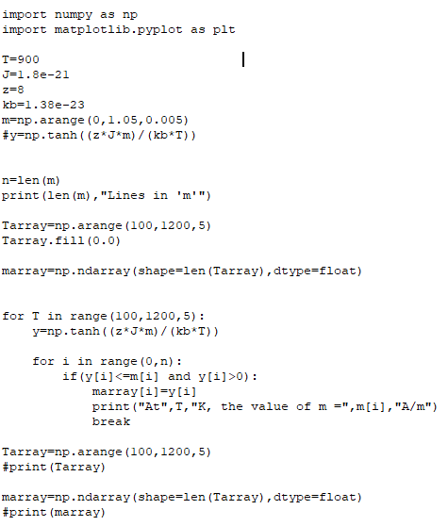

**Fig 1.13:** Code to see how magnetization, $m$ varies with temperature $T$ increases.

The shell prints out a long list of variables, but we will focus on a small sample, show below (**Fig1.14**)

Here we can see that at the temperature, $T$ increases the magnetization, $m$ decreases.

I picked this sample because it agrees with our solution for the first bit of code (**Fig 1.1**) where $m=0.61 A/m$ at $T=900 K$

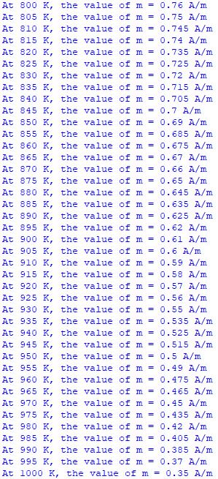

**Fig 1.14:** Small sample of what printed to the shell using code from **Fig 1.13.**

It also agrees with the values for $m$ when $T=800 K$ and $T=1000 k$ which we found previously.



**Fig 1.12:** Code to plot solution to 2b from **Fig1.1**

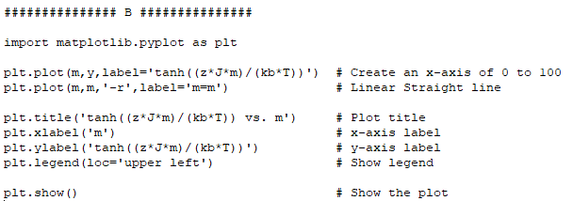

**Fig 1.2:** Plot of solution to 1a. Where $m=0.61$

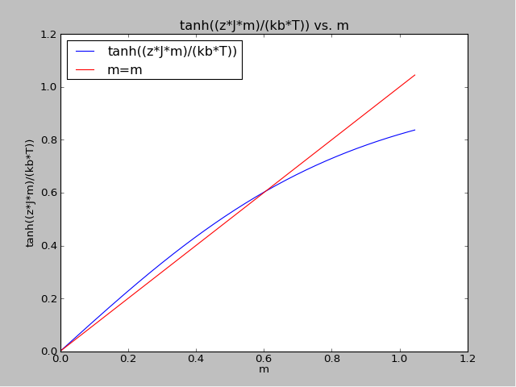

The two lines cross at $T=0 K$ and $T=900 K$.

**Question 2**



(1.1)

$$m=\tanh\left(\frac{μ_{o}μ_{b}H}{k_{B}T_{C}}+\frac{zJm}{k_{B }T_{C}}\right)$$

Diffracting **Eq.1.1** with respect to $m$,

For LHS,

$$\frac{d}{dm}=1$$

For RHS,

$$\frac{d}{dm}=\frac{zJ}{k_{B}T}{sech}^{2}\left(\frac{μ_{o}μ_{b}H}{k_{B}T_{C}}+\frac{zJm}{k_{B }T_{C}}\right)$$

Subbing in $m=0$ and $H=0$ and combining the LHS and RHS we have that,

$$\frac{d}{dm}=\frac{zJ}{K_{B}T_{C}}=1$$

Hence, we can rearrange so say that



$$zJ=K_{B}T_{C}$$

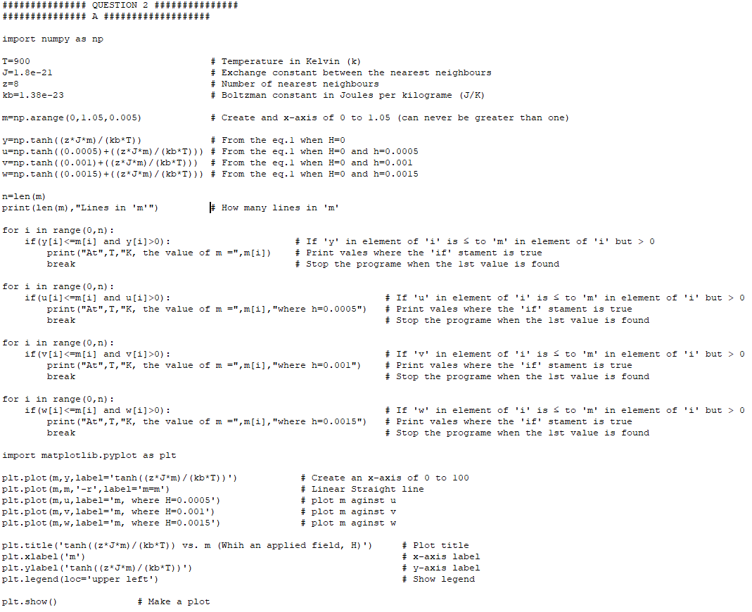

**Fig 2.1:** Written code for question 2b.

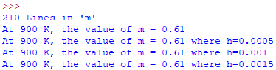

**Fig 2.2:** What was printed to the shell from **Fig 2.1.**

With the given values for the applied field, $h$. It can be seen that the magnetisation remains unchanged as per what was printed into the shell. We can see this visually shown in the plot below (**Fig2.3**)

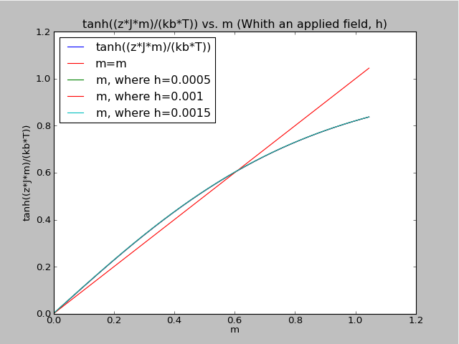

**Fig 2.3:** Plot of solutions to 2b.

However if we were to increase each value of of $H$ by two factors of $10$. The graph yeilds difrrent results (**Fig.2.4**)

**Fig 2.4:** Plot of solutions to 2b. When $H$ has been increased.

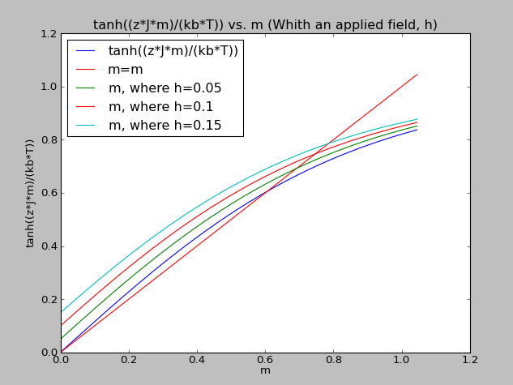

The shell also printed new values for $m$. Shown below.

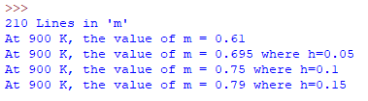

**Fig 2.5:** What was printed to the shell when $h$ was increased by 2 factors of 10.



The magnetisation increased as the applied field, $h$. $m$ did also. This means you could increase the magnetization of a material with an applied field, when the material is of a higher temperature.